Classroom Recycling |  | Back in 2018, Environmental Club discovered that anything being recycled was really just being thrown in the garbage dump. The custodial staff simply does not have enough time or manpower, so the environmental club took it upon themselves to do weekly recycling for the school.  Every Tuesday, teachers put out their recycling from the week and students pick it up. | See below for weekly email to staff  See below for student sign up  200lbs collected a week x 34 school weeks- 6,800 lbs a year
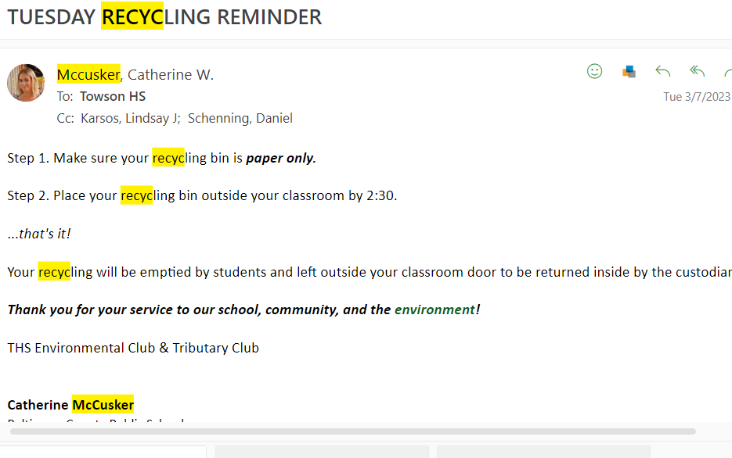
RECYCLING EVIDENCE
